Practical No. 01

Demonstrate the different types of topologies and types of transmission media by using a packet tracer tool.
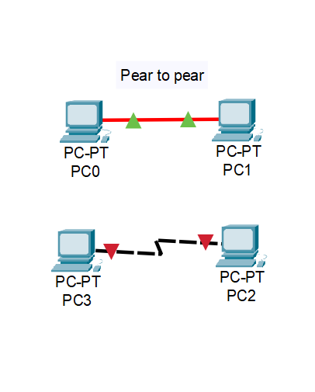
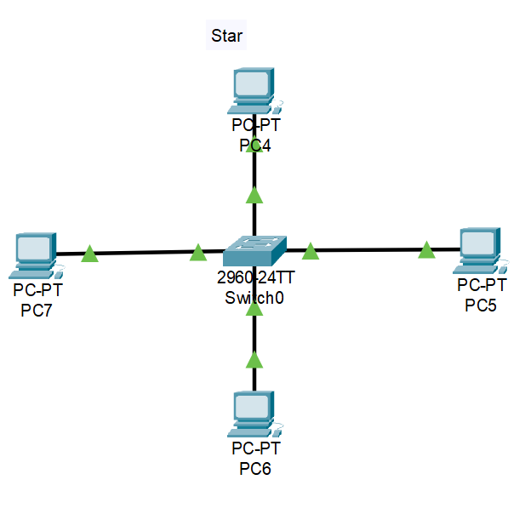

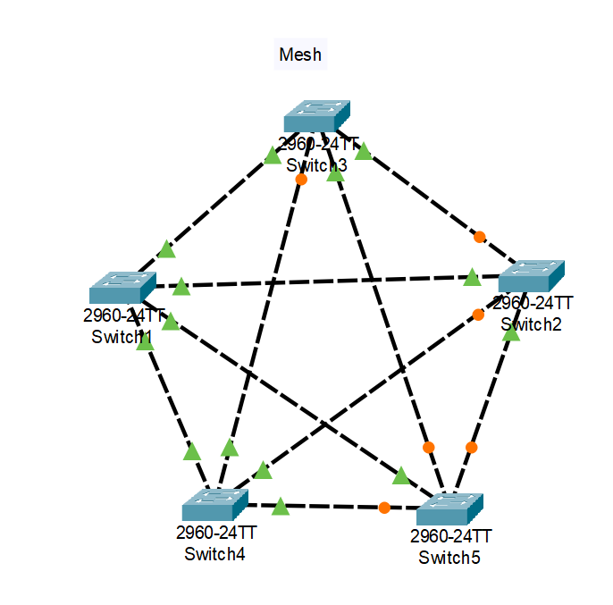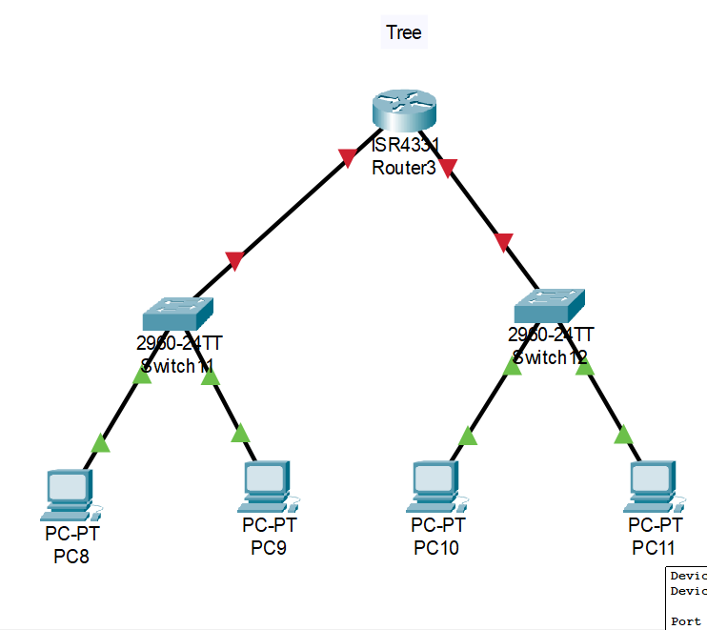

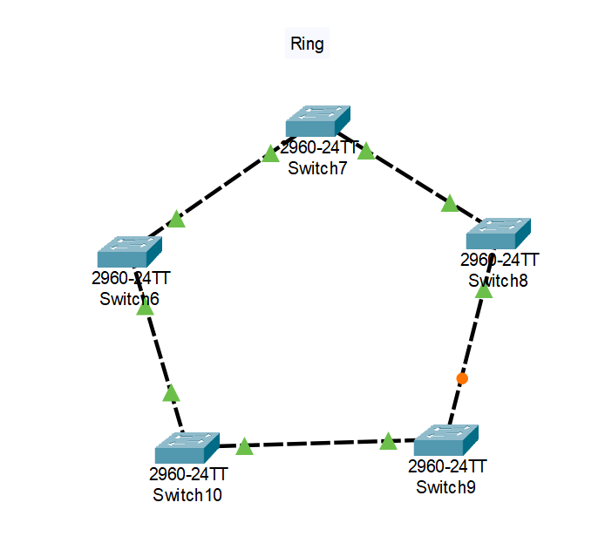

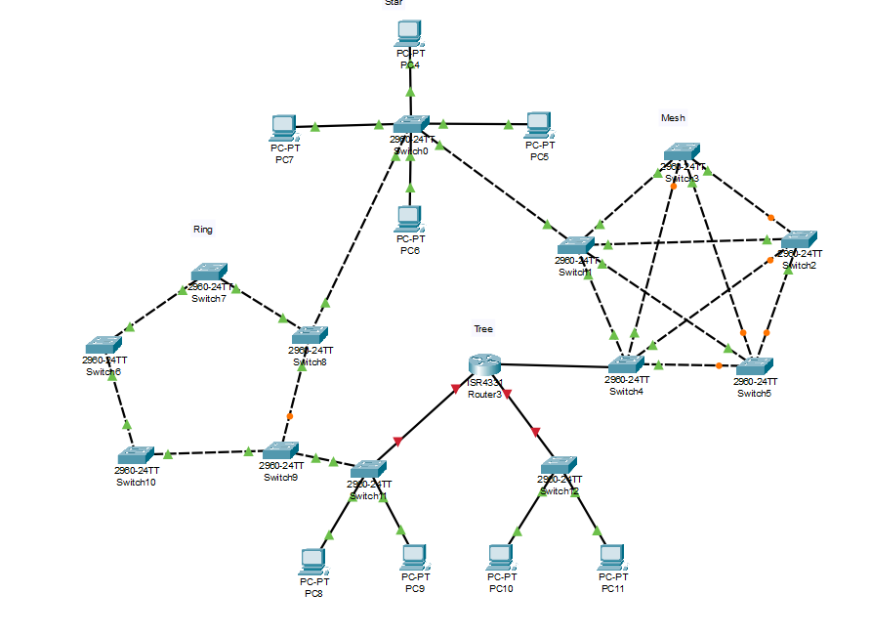

Practical No. 02

Setup a wired LAN using Layer 2 Switch. It includes preparation of cable, testing of cable using line tester, configuration machine using IP addresses, testing using PING utility and demonstrating the PING packets captured traces using Wireshark Packet Analyzer Tool.

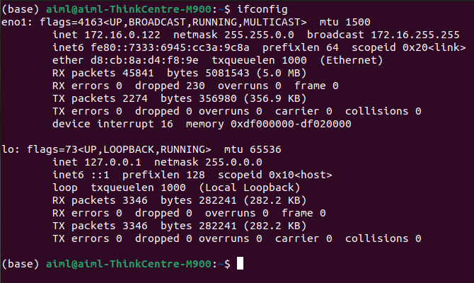

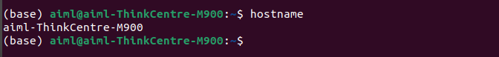

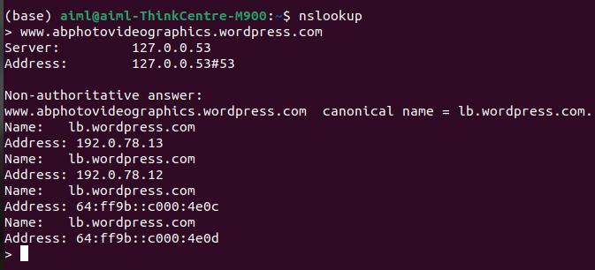

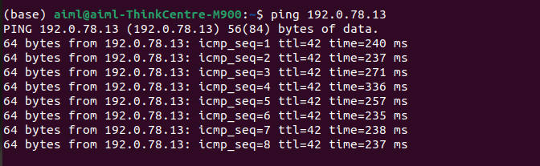

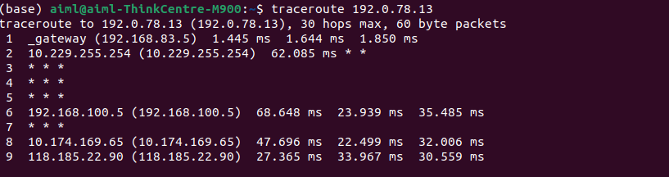
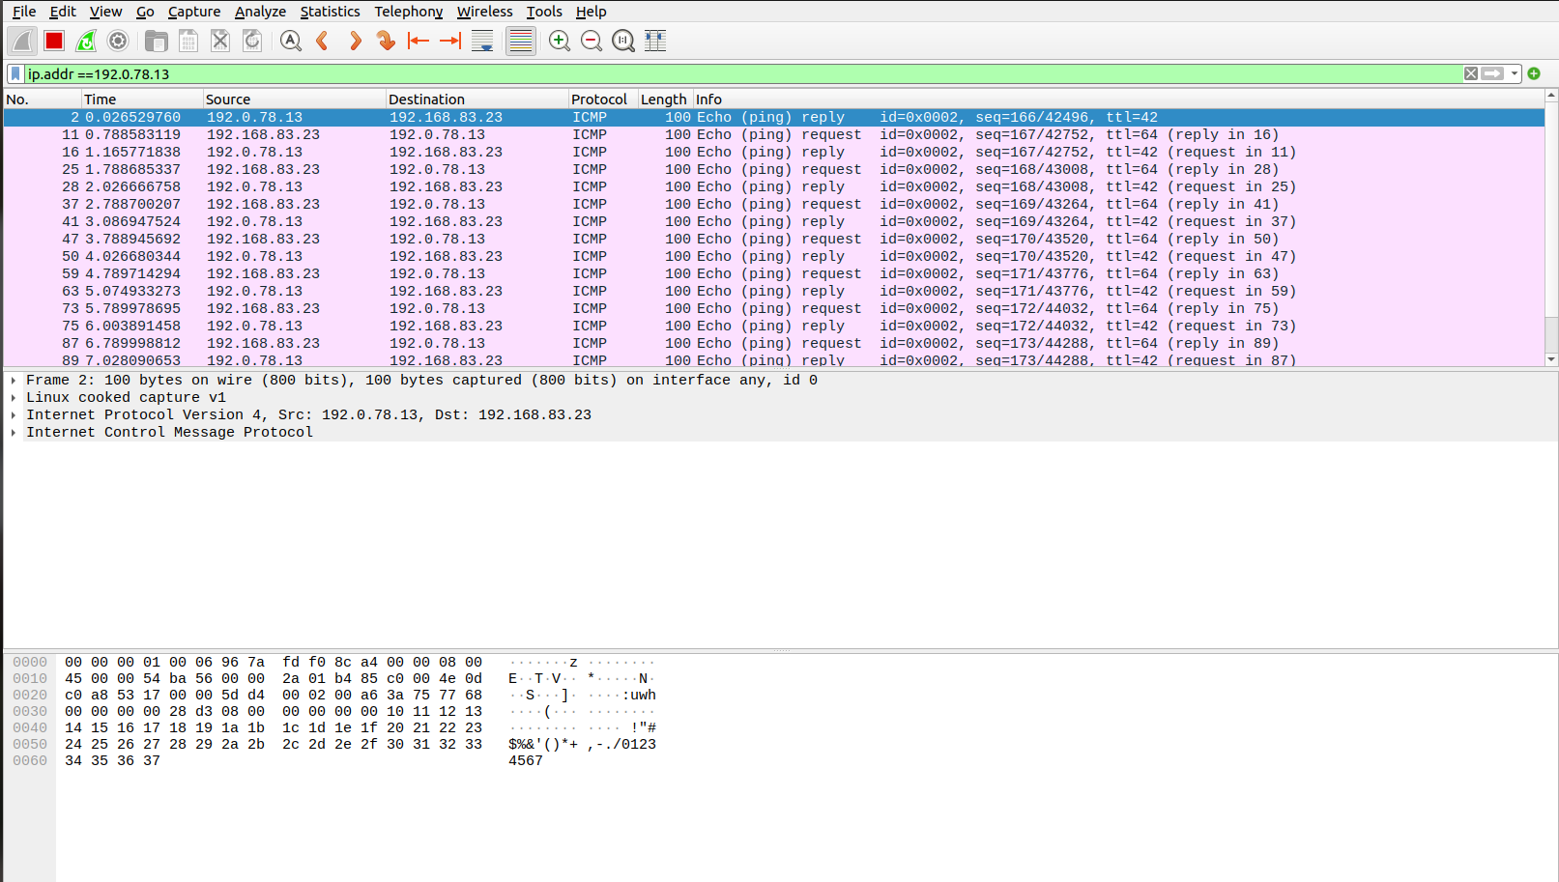

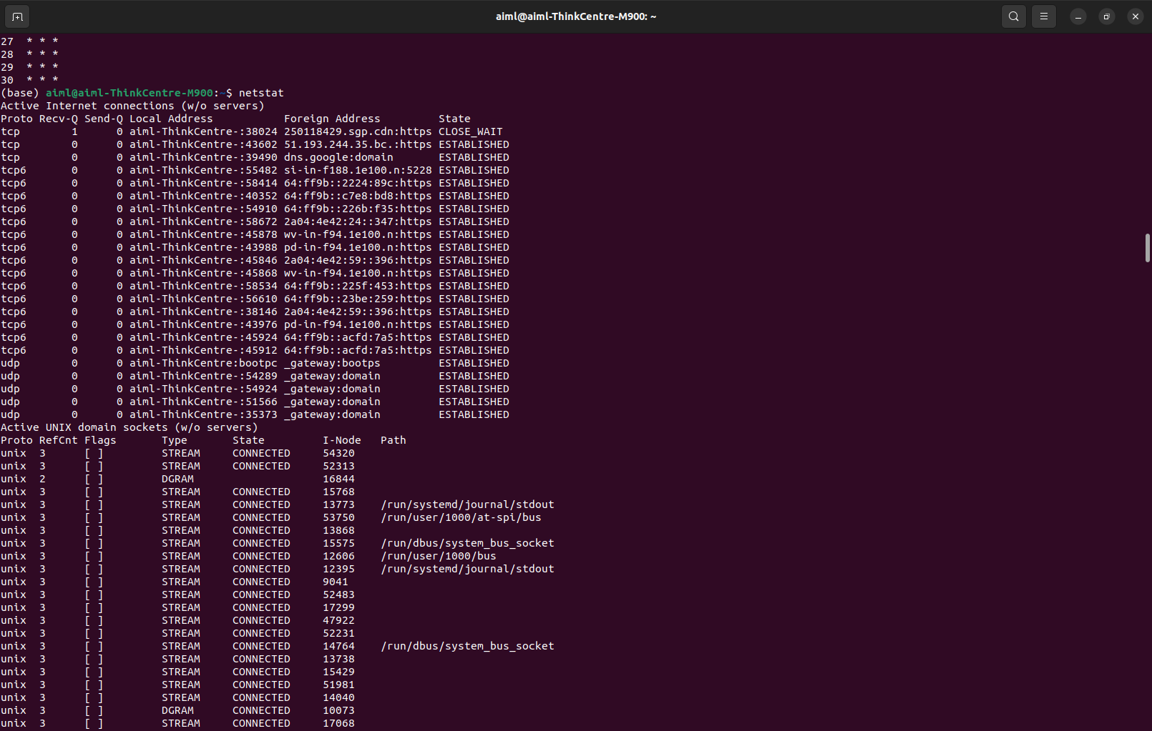

Practical No. 03

Setup a WAN which contains wired as well as wireless LAN by using a packet tracer tool. Demonstrate transfer of a packet from LAN 1 (wired LAN) to LAN2 (Wireless LAN).
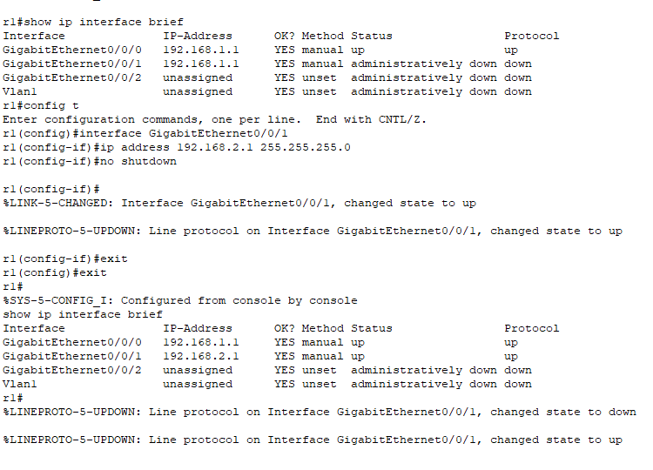

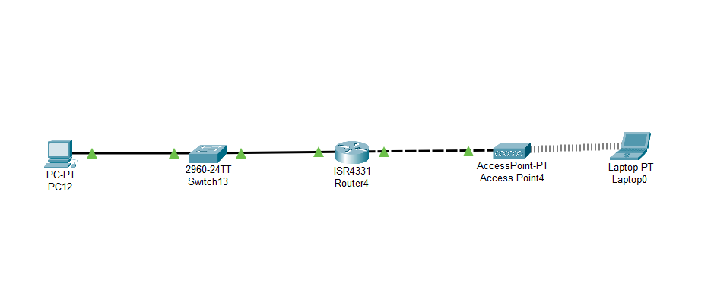

Practical No. 04

Write a program to demonstrate Sub-netting and find subnet masks.

import java.util.*;

public class ipcheck {
public static void main(String[] args) {
Scanner sc = new Scanner(System.in);
System.out.print("Enter IPv4 address (e.g. 192.168.0.1): ");
String ip = sc.nextLine().trim();

if (!isValidIPv4(ip)) {
System.out.println("Invalid IPv4 address format.");
return;
}

int firstOctet = Integer.parseInt(ip.split("\\.")[0]);
char ipClass = getClassOfIp(firstOctet);

String subnetMask = getDefaultSubnetMask(ipClass);

System.out.println("IP address " + ip + " belongs to Class " + ipClass);
System.out.println("Default subnet mask: " + subnetMask);
}

static boolean isValidIPv4(String ip) {
String[] parts = ip.split("\\.");
if (parts.length != 4) return false;
for (String part : parts) {
if (part.length() == 0) return false;
if (part.length() > 1 && part.charAt(0) == '0') return false;
try {
int num = Integer.parseInt(part);
if (num < 0 || num > 255) return false;
} catch (NumberFormatException e) {
return false;
}
}
return true;
}

static char getClassOfIp(int firstOctet) {
if (firstOctet >= 0 && firstOctet <= 127) return 'A';
else if (firstOctet >= 128 && firstOctet <= 191) return 'B';
else if (firstOctet >= 192 && firstOctet <= 223) return 'C';
else if (firstOctet >= 224 && firstOctet <= 239) return 'D';
else return 'E';
}

static String getDefaultSubnetMask(char ipClass) {
switch (ipClass) {
case 'A': return "255.0.0.0";
case 'B': return "255.255.0.0";
case 'C': return "255.255.255.0";
case 'D': return "Class D (multicast) has no default mask";
case 'E': return "Class E (reserved) has no default mask";
default: return "Unknown class";
}
}
}

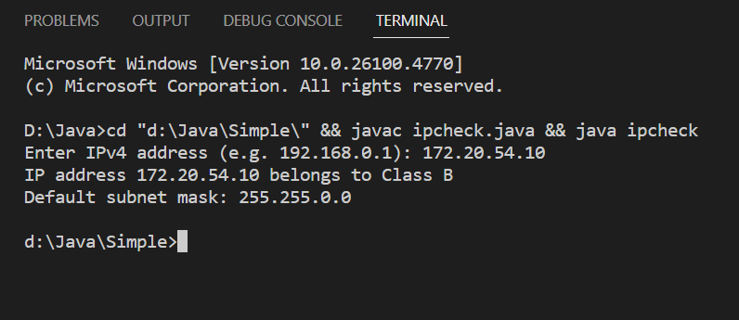

Practical No. 05
Socket Programming using C/C++/Java.
- TCP Client, TCP Server
TCPServer:

import java.io.*;
import java.net.*;

public class TCPServer {
public static void main(String[] args) throws IOException {
ServerSocket serverSocket = new ServerSocket(5000); // Server at port 5000
System.out.println("Server started. Waiting for client...");

Socket socket = serverSocket.accept(); // Accept client connection
System.out.println("Client connected.");

BufferedReader input = new BufferedReader(new InputStreamReader(socket.getInputStream()));
PrintWriter output = new PrintWriter(socket.getOutputStream(), true);

String clientMessage = input.readLine();
System.out.println("Client says: " + clientMessage);

output.println("Hello from Server!");

socket.close();
serverSocket.close();
}
}

TCPClient:

import java.io.*;
import java.net.*;

public class TCPClient {
public static void main(String[] args) throws IOException {
Socket socket = new Socket("localhost", 5000); // Connect to server

BufferedReader input = new BufferedReader(new InputStreamReader(socket.getInputStream()));
PrintWriter output = new PrintWriter(socket.getOutputStream(), true);

output.println("Hello from Client!");

String serverMessage = input.readLine();
System.out.println("Server says: " + serverMessage);
System.out.println(" Mr.AB ");

socket.close();
}
}

Output:-

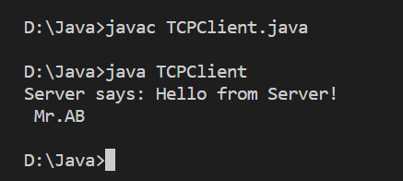

b. UDP Client, UDP Serve

UDPClient:

import java.net.*;

public class UDPClient {
public static void main(String[] args) throws Exception {
DatagramSocket socket = new DatagramSocket();

InetAddress serverAddress = InetAddress.getByName("localhost");
byte[] sendData = "Hello from UDP Client!".getBytes();

DatagramPacket sendPacket = new DatagramPacket(sendData, sendData.length, serverAddress, 6000);
socket.send(sendPacket);

byte[] receiveData = new byte[1024];
DatagramPacket receivePacket = new DatagramPacket(receiveData, receiveData.length);
socket.receive(receivePacket);

String serverMsg = new String(receivePacket.getData(), 0, receivePacket.getLength());
System.out.println("Server says: " + serverMsg);
System.out.println(" Mr.AB " );

socket.close();
}
}

UDPServer:

import java.net.*;

public class UDPServer {
public static void main(String[] args) throws Exception {
DatagramSocket socket = new DatagramSocket(6000);
byte[] receiveData = new byte[1024];

System.out.println("UDP Server started...");

DatagramPacket receivePacket = new DatagramPacket(receiveData, receiveData.length);
socket.receive(receivePacket);

String clientMsg = new String(receivePacket.getData(), 0, receivePacket.getLength());
System.out.println("Client says: " + clientMsg);

String reply = "Hello from UDP Server!";
byte[] sendData = reply.getBytes();

InetAddress clientAddress = receivePacket.getAddress();
int clientPort = receivePacket.getPort();

DatagramPacket sendPacket = new DatagramPacket(sendData, sendData.length, clientAddress, clientPort);
socket.send(sendPacket);

socket.close();
}
}

Output:

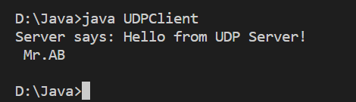

Practical No. 06

Study and Analyze the performance of HTTP, HTTPS and FTP protocol using Packet tracer tool.

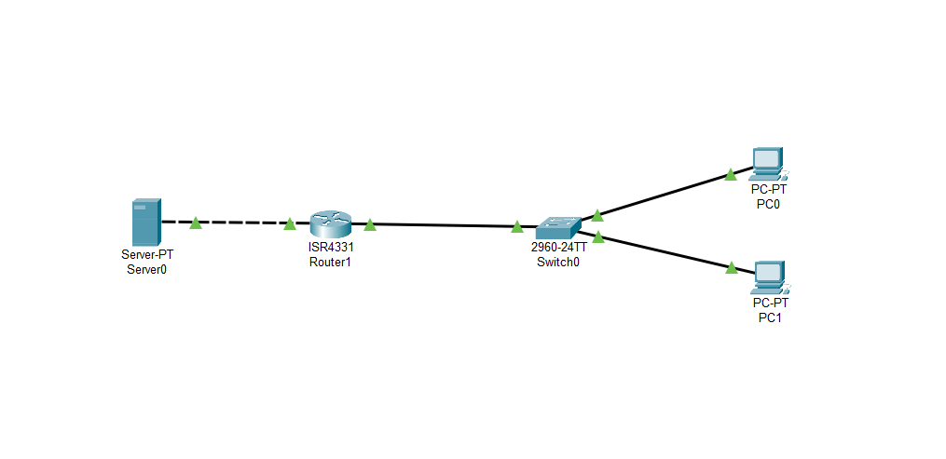
Get the HTTP file

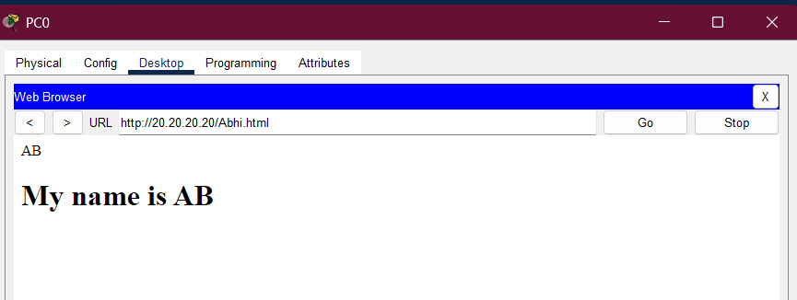

Put The txt file on server

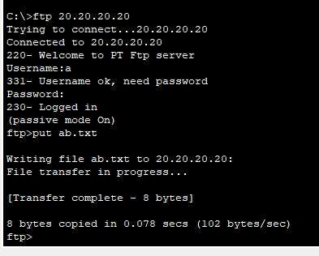

Get The txt file from server
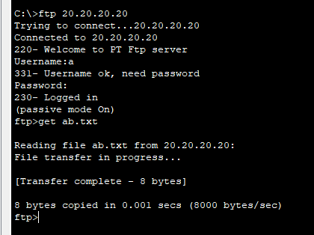

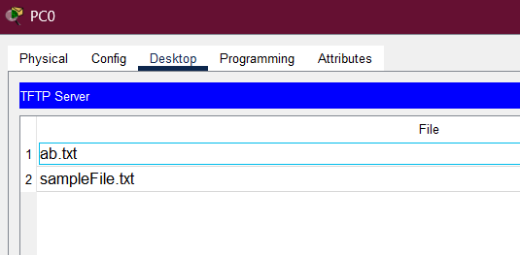

Practical No. 06

Name: Bhong Abhijit
Roll No. 29
Write a program using TCP socket for wired network for following
a. Say Hello to Each other

Server.java
import java.net.ServerSocket;
import java.net.Socket;
import java.io.BufferedReader;
import java.io.InputStreamReader;
import java.io.PrintWriter;
import java.io.IOException;

public class server {
public static void main(String[] args) {
final int PORT = 2019;
System.out.println("Server started, waiting for client on port " + PORT);
try ( ServerSocket serverSocket = new ServerSocket(PORT);
Socket clientSocket = serverSocket.accept();
BufferedReader in = new BufferedReader(new InputStreamReader(clientSocket.getInputStream()));
PrintWriter out = new PrintWriter(clientSocket.getOutputStream(), true) ) {

System.out.println("Client connected: " + clientSocket.getRemoteSocketAddress());
String userInput;
while ((userInput = in.readLine()) != null) {
System.out.println("Received from client: " + userInput);
if (userInput.trim().equalsIgnoreCase("hello")) {
out.println("hello client");
} else {
out.println("you did not say hello to server");
}
}
} catch (IOException e) {
System.err.println("IOException: " + e.getMessage());
e.printStackTrace();
}
System.out.println("Server shutting down.");
}
}

Client.java

import java.net.Socket;
import java.io.BufferedReader;
import java.io.InputStreamReader;
import java.io.PrintWriter;
import java.io.IOException;

public class client {
public static void main(String[] args) {
final String HOST = "localhost";
final int PORT = 2019;

try ( Socket socket = new Socket(HOST, PORT);
BufferedReader consoleReader = new BufferedReader(new InputStreamReader(System.in));
BufferedReader in = new BufferedReader(new InputStreamReader(socket.getInputStream()));
PrintWriter out = new PrintWriter(socket.getOutputStream(), true) ) {

System.out.print("Hello to server: ");
String userInput = consoleReader.readLine();
out.println(userInput);

String response = in.readLine();
System.out.println("Server replied: " + response);

} catch (IOException e) {
System.err.println("IOException: " + e.getMessage());
e.printStackTrace();
}
}
}

Output:-
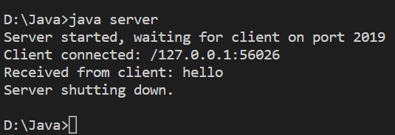

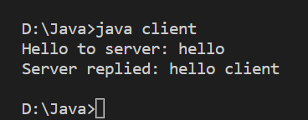

b. File transfer
FileClient:

import java.io.*;
import java.net.*;

public class FileClient {
public static void main(String[] args) throws IOException {
Socket socket = new Socket("localhost", 6000);
System.out.println("Connected to Server.");

DataOutputStream dos = new DataOutputStream(socket.getOutputStream());
String filePath = "test.txt"; // Example file in same folder

// Send file name
File file = new File(filePath);
dos.writeUTF(file.getName());

// Send file data
FileInputStream fis = new FileInputStream(file);
byte[] buffer = new byte[4096];
int bytesRead;
while ((bytesRead = fis.read(buffer)) != -1) {
dos.write(buffer, 0, bytesRead);
}

System.out.println("File sent successfully. From Mr.AB:");

fis.close();
dos.close();
socket.close();
}
}

FileServer:

import java.io.*;
import java.net.*;

public class FileServer {
public static void main(String[] args) throws IOException {
ServerSocket serverSocket = new ServerSocket(6000);
System.out.println("File Server started. Waiting for client...");

Socket socket = serverSocket.accept();
System.out.println("Client connected.");

// Receive file name first
DataInputStream dis = new DataInputStream(socket.getInputStream());
String fileName = dis.readUTF();
FileOutputStream fos = new FileOutputStream("Received_" + fileName);

// Receive file data
byte[] buffer = new byte[4096];
int bytesRead;
while ((bytesRead = dis.read(buffer)) != -1) {
fos.write(buffer, 0, bytesRead);
}

System.out.println("File received successfully: Received_" + fileName);

fos.close();
dis.close();
socket.close();
serverSocket.close();
}
}

Output:

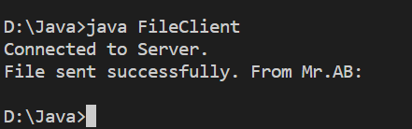

Practical No. 07

Write a program using UDP Sockets to enable file transfer (Script, Text, Audio and Video one file each) between two machines.

Server.java
import java.net.ServerSocket;
import java.net.Socket;
import java.io.BufferedReader;
import java.io.InputStreamReader;
import java.io.PrintWriter;
import java.io.IOException;

public class server {
public static void main(String[] args) {
final int PORT = 2019;
System.out.println("Server started, waiting for client on port " + PORT);
try ( ServerSocket serverSocket = new ServerSocket(PORT);
Socket clientSocket = serverSocket.accept();
BufferedReader in = new BufferedReader(new InputStreamReader(clientSocket.getInputStream()));
PrintWriter out = new PrintWriter(clientSocket.getOutputStream(), true) ) {

System.out.println("Client connected: " + clientSocket.getRemoteSocketAddress());
String userInput;
while ((userInput = in.readLine()) != null) {
System.out.println("Received from client: " + userInput);
if (userInput.trim().equalsIgnoreCase("hello")) {
out.println("hello client");
} else {
out.println("you did not say hello to server");
}
}
} catch (IOException e) {
System.err.println("IOException: " + e.getMessage());
e.printStackTrace();
}
System.out.println("Server shutting down.");
}
}

Client.java

import java.net.Socket;
import java.io.BufferedReader;
import java.io.InputStreamReader;
import java.io.PrintWriter;
import java.io.IOException;

public class client {
public static void main(String[] args) {
final String HOST = "localhost";
final int PORT = 2019;

try ( Socket socket = new Socket(HOST, PORT);
BufferedReader consoleReader = new BufferedReader(new InputStreamReader(System.in));
BufferedReader in = new BufferedReader(new InputStreamReader(socket.getInputStream()));
PrintWriter out = new PrintWriter(socket.getOutputStream(), true) ) {

System.out.print("Hello to server: ");
String userInput = consoleReader.readLine();
out.println(userInput);

String response = in.readLine();
System.out.println("Server replied: " + response);

} catch (IOException e) {
System.err.println("IOException: " + e.getMessage());
e.printStackTrace();
}
}
}

Output:-

Practical No. 09

Study and Analyze the performance of HTTP, HTTPS and FTP protocol using Packet tracer tool.
Server.java

Output:-

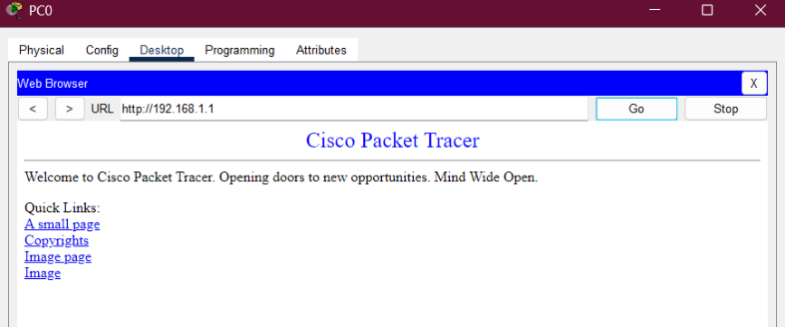
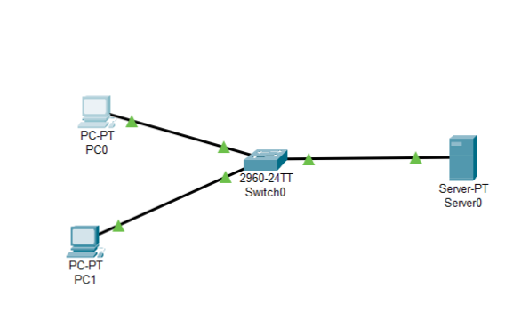

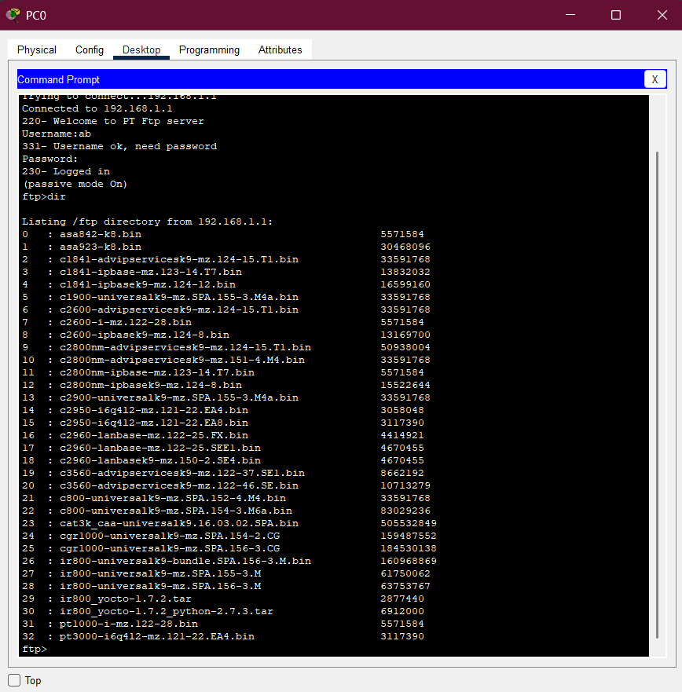

Practical No. 10

Name: Bhong Abhijit
Roll No. 29
To study the SSL protocol by capturing the packets using Wireshark tool while visiting any SSL secured website (banking, e-commerce etc.).

Output:-
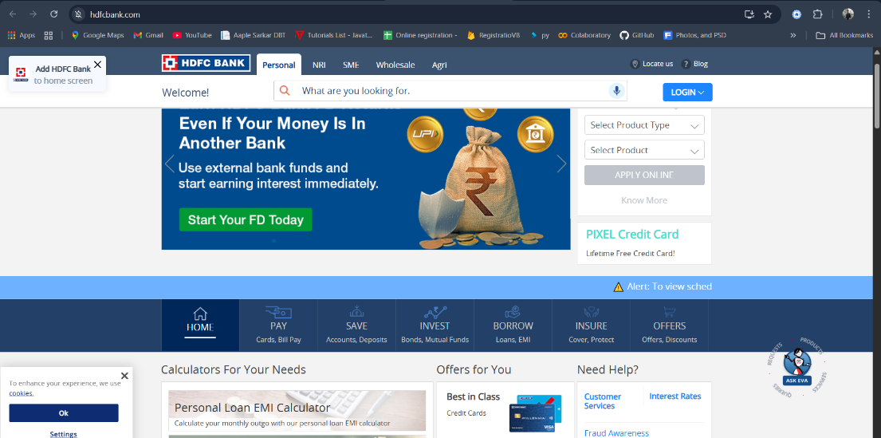

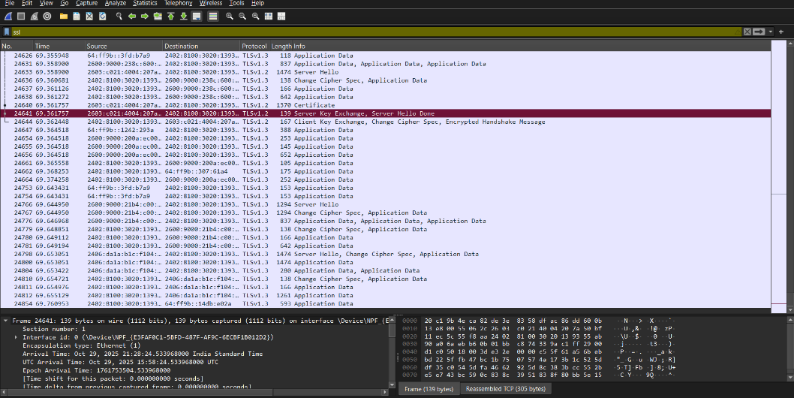

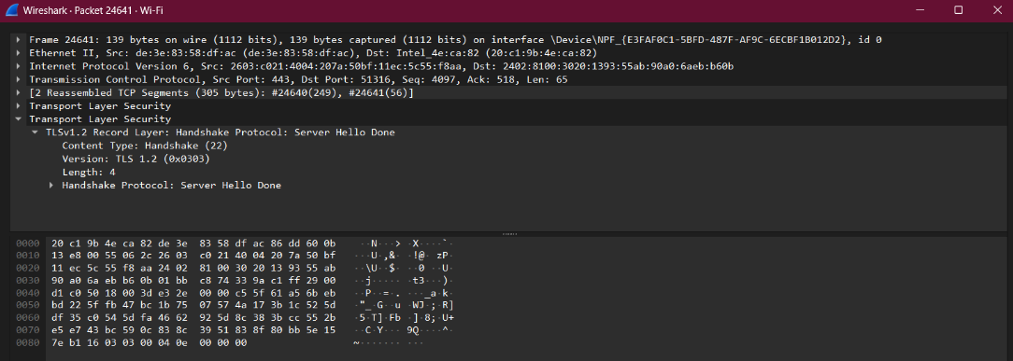

Practical No. 11

Installing and configuring DHCP server and assign IP addresses to client machines using DHCP server.

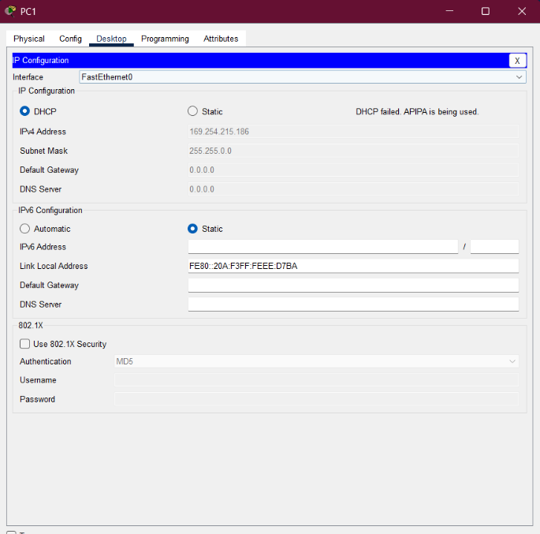
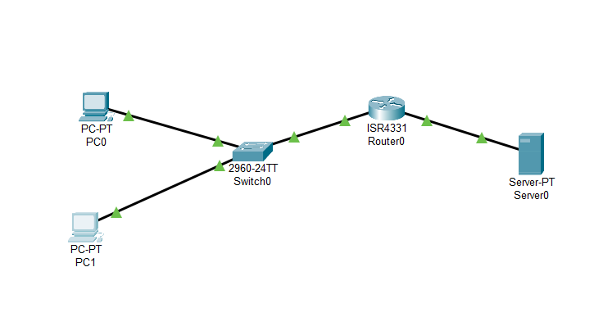
Output:-
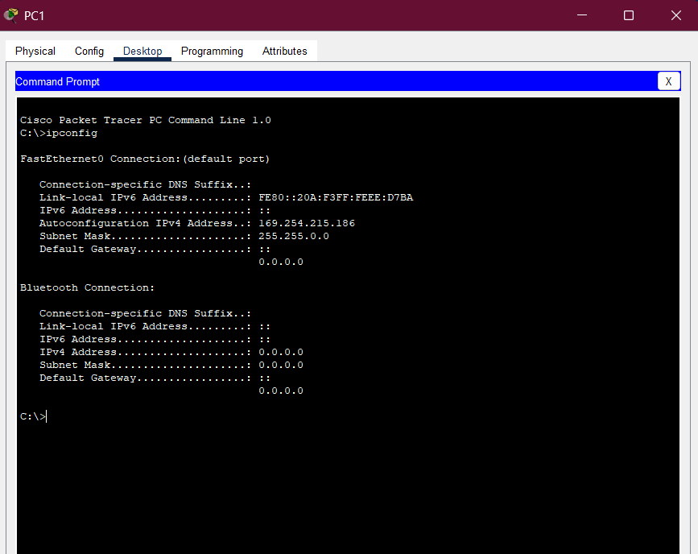

Practical No. 12
Write a program for DNS lookup. Given an IP address input, it should return URL and vice versa.

Program:

import java.net.*;
import java.util.Scanner;

public class DNSLookup {
public static void main(String[] args) {
Scanner sc = new Scanner(System.in);
System.out.println("Mr.AB");
System.out.println("Enter '1' for Domain to IP lookup");
System.out.println("Enter '2' for IP to Domain lookup");
System.out.print("Your choice: ");
int choice = sc.nextInt();
sc.nextLine(); // consume newline

try {
if (choice == 1) {
System.out.print("Enter domain name (e.g., www.google.com): ");
String domain = sc.nextLine();
InetAddress ip = InetAddress.getByName(domain);
System.out.println("IP Address: " + ip.getHostAddress());
}
else if (choice == 2) {
System.out.print("Enter IP address (e.g., 142.250.183.36): ");
String ipStr = sc.nextLine();
InetAddress addr = InetAddress.getByName(ipStr);
System.out.println("Host Name: " + addr.getHostName());
}
else {
System.out.println("Invalid choice!");
}
}
catch (UnknownHostException e) {
System.out.println("Unable to resolve host/IP: " + e.getMessage());
}

sc.close();
}
}

Output:-
